**The Façade Patten:**

1. **Definition**: The Façade Pattern provide simplified interface to a set of interfaces in a subsystem. Façade defines a higher-level interface that make the system easier to use.
   1. **Advantage**: We can upgrade the subsystem classes without changing client since client is coded to façade class.
   2. A facades intent is to simplify an interface where an adapter intent is to change an interface to client interface.

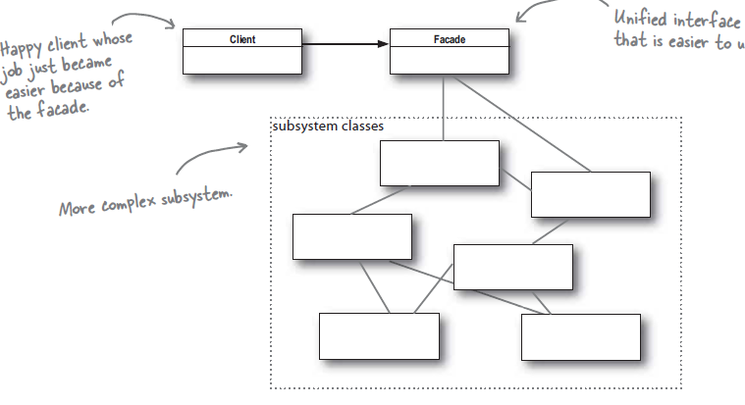

1. **Principle of Least knowledge/demeter:** Talk only to your immediate friends. This prevents us from creating large number of coupled classes such that changes in one class cascade to other classes.
   1. **Guideline**: From any method in an object we should only invoke methods of:
      1. The object itself.
      2. Any components of the object.
      3. Any method of object that it creates or instantiates.
      4. Object passed in as parameter to the method.

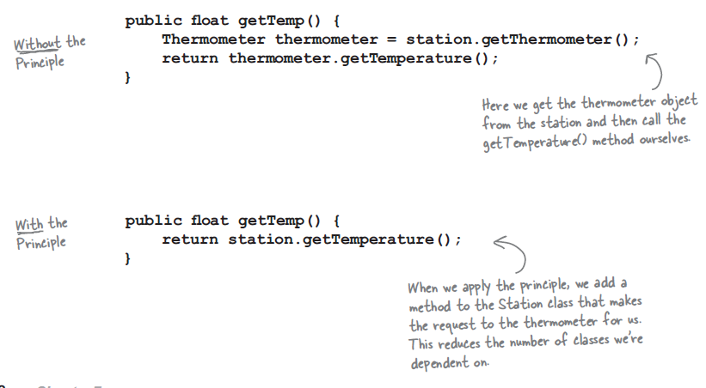

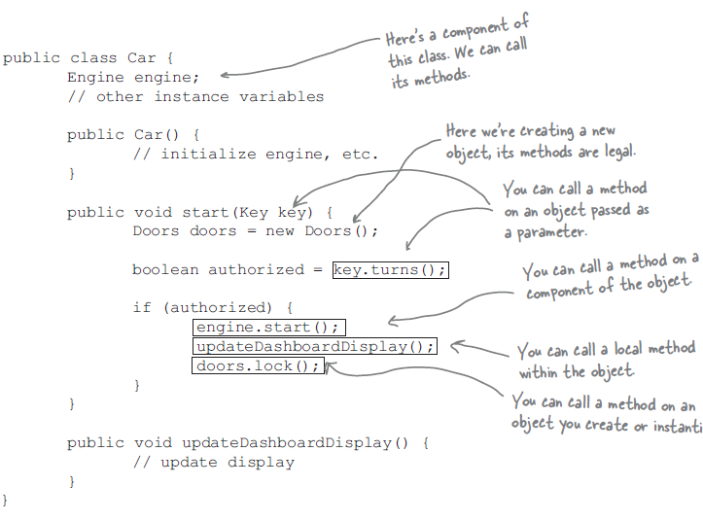

* 1. **Disadvantages:** While this principle reduces coupling between objects this results in more wrapper classes thus increasing development time and decreasing runtime performance.

